
SMART HOSPITAL BED MANAGEMENT SYSTEM
A Runtime Polymorphism Based C++ Solution for Dynamic Patient Classification, Bed Allocation, Monitoring and Billing
Course Name: OBJECT ORINTED PROGRAMMING (OOP) IN C++
Course Code: DSA0101
to the award of the degree of
BACHELOR OF ENGINEERING / BACHELOR OF TECHNOLOGY
IN
COMPUTER SCIENCE ENGINEERING
Submitted by
A.Virender Singh (1911260054)
Under the Supervision of
Dr. Parimala Kanaga Devan K
Professor
SIMATS ENGINEERING
Saveetha Institute of Medical and Technical Sciences
Chennai-602105
SEPTEMBER 2026

CERTIFICATE
This is to certify that the project report entitled “SMART HOSPITAL BED MANAGEMENT SYSTEM: A Runtime Polymorphism Based C++ Solution for Dynamic Patient Classification, Bed Allocation, Monitoring and Billing” is a bona fide record of work carried out by A.VIRENDER SINGH, Register Number 1911260054, in fulfillment of the requirements of the course COMPUTER SCIENCE AND ENGINEERING during the academic year 2026-2029.
The project demonstrates the application of Object-Oriented Programming principles using C++, with particular emphasis on Runtime Polymorphism, inheritance, abstraction, encapsulation, virtual functions, smart pointers, STL collections, and operator overloading.
The work presented in this report has been completed under the guidance and supervision of the undersigned.
COURSE COORDINATOR | COURSE FACULTY
Dr. C. Sivasankar  Professor  Department of CSE,  Saveetha School of Engineering,  SIMATS, Chennai. | Dr. Parimala Kanaga Devan K  Professor  Department of CSE  Saveetha School of Engineering,  SIMATS, Chennai.

DECLARATION
I, A.VIRENDER SINGH, Register Number 1911260054, Department of COMPUTER SCIENCE ENGINEERING, hereby declare that the project report entitled “SMART HOSPITAL BED MANAGEMENT SYSTEM: A Runtime Polymorphism Based C++ Solution for Dynamic Patient Classification, Bed Allocation, Monitoring and Billing” is an authentic record of the work carried out by me under the guidance of Dr. Parimala Kanaga Devan K .
I further declare that this project has been developed as an academic implementation of Object-Oriented Programming concepts in C++. The project particularly demonstrates Runtime Polymorphism through an abstract Patient base class and specialized derived classes representing General, ICU, and Emergency patients.
I confirm that the work presented in this report has not been submitted previously, either wholly or partly, for the award of any degree, diploma, or academic qualification at any other institution.
All external references, theoretical concepts, software documentation, and other sources used during the development of this project have been acknowledged appropriately.
Place: CHENNAI Date: 03/09/2026
Signature of Student:
A.VIRENDER SINGH
1911260054

ACKNOWLEDGEMENT
I express my sincere gratitude to, my course instructor and project guide, for providing valuable guidance, technical suggestions, continuous encouragement, and constructive feedback throughout the development of the Smart Hospital Bed Management System.
The guidance received during the study of Object-Oriented Programming, particularly in the areas of inheritance, abstraction, virtual functions, dynamic binding, and runtime polymorphism, played an important role in designing the architecture of this project.
I would also like to thank Dr. C. Sivasankar Professor Department of CSE,, and the management SIMATS ENGINEERING for providing the required laboratory facilities, computer systems, software tools, and academic environment necessary for completing this project.
I extend my sincere appreciation to my classmates and friends who provided useful suggestions during the design, coding, testing, and debugging stages of the application.
Finally, I thank my family for their continuous encouragement and support throughout the completion of this academic project.
Student Name:
A.VIRENDER SINGH
Register number:
1911260054

ABSTRACT
Hospital bed management is an important administrative activity because hospitals must continuously coordinate available beds with patients having different levels of care requirements. General patients, ICU patients, and Emergency patients do not require the same type of bed, monitoring frequency, priority, or billing structure. A software system designed to manage these differences must therefore provide flexible mechanisms for representing patient-specific behavior.
The Smart Hospital Bed Management System is a console-based C++ application developed using Object-Oriented Programming principles. The central design concept of the project is Runtime Polymorphism. Instead of implementing patient-specific behavior through large if-else or switch structures, the system defines an abstract base class named Patient and derives specialized classes such as GeneralPatient, ICUPatient, and EmergencyPatient.
The abstract Patient class defines a common interface through virtual functions such as getPatientType(), getRequiredBedType(), getDailyCharge(), getServiceCharge(), getMonitoringPlan(), and getPriorityScore(). Each derived patient class overrides these functions according to its specific requirements. The Hospital class stores heterogeneous patient objects using std::vector<std::unique_ptr<Patient>>. When the hospital controller calls a virtual function through a base-class pointer, C++ dynamically selects the appropriate derived implementation at runtime.
The system provides facilities for patient registration, patient display, dynamic bed allocation, monitoring-unit updates, billing calculation, patient discharge, bed release, admission comparison, and hospital utilization reporting.
The project also demonstrates other important C++ concepts including inheritance, encapsulation, abstraction, virtual destructors, smart pointers, STL vectors, constructors, operator overloading, modular multi-file development, input validation, and structured testing.
The project demonstrates that Runtime Polymorphism can reduce dependency between the central hospital controller and specific patient categories. If a new patient category is introduced in the future, a new derived class can implement the existing Patient interface without requiring major changes to the central hospital management logic.
Keywords: C++, Object-Oriented Programming, Runtime Polymorphism, Virtual Functions, Dynamic Binding, Hospital Bed Management, Inheritance, Abstraction, Smart Pointers.

List of Tables
Table No. | Table Title
Table 10.1 | Operational Parameters of Patient Categories
Table 14.1 | Hardware and Software Requirements
Table 18.1 | Virtual Function Mapping
Table 18.2 | Runtime Dispatch Analysis
Table 20.1 | Requirement-to-Implementation Mapping
Table 27.1 | System Test Case Matrix
Table 31.1 | Procedural Approach versus Polymorphic Architecture
Table 42.1 | Final Requirement Verification Audit
List of Figures
Figure No. | Figure Title
Figure 15.1 | UML Use Case Diagram of the Smart Hospital Bed Management System
Figure 16.1 | System Architecture Diagram
Figure 17.1 | UML Class Diagram
Figure 23.1 | Overall System Execution Flowchart
Figure 25.1 | Multi-file Project Directory Structure
Figure 26.1 | C++ Compilation and Execution in VS Code
Figure 28.1 | Main Menu Execution
Figure 28.2 | General Patient Registration
Figure 28.3 | ICU Patient Registration
Figure 28.4 | Emergency Patient Registration
Figure 28.5 | Patient Display
Figure 28.6 | Initial Bed Status
Figure 28.7 | General Patient Bed Allocation
Figure 28.8 | ICU Patient Bed Allocation
Figure 28.9 | Emergency Patient Bed Allocation
Figure 28.10 | Monitoring Unit Update
Figure 28.11 | Dynamic Billing Calculation
Figure 28.12 | Admission Records
Figure 28.13 | Admission Comparison
Figure 28.14 | Hospital Utilization Report
Figure 28.15 | Patient Discharge and Bed Release
Figure 28.16 | Input Validation and Error Handling
Table of Contents
Section | Topic
9. | Introduction
9.1 | Background
9.2 | Motivation
9.3 | Importance of Runtime Polymorphism
10. | Real-World Background
10.1 | Hospital Bed Management
10.2 | Patient Categories
10.3 | Operational Parameters
10.4 | Problems with Manual Management
10.5 | Software Engineering Perspective
11. | Problem Statement
12. | Objectives
12.1 | Primary Objective
12.2 | Secondary Objectives
13. | Scope of the Project
13.1 | In-Scope Features
13.2 | Out-of-Scope Features
13.3 | System Boundary
14. | System Requirements
14.1 | Hardware Requirements
14.2 | Software Requirements
14.3 | Development Environment
14.4 | C++ Standard
15. | Proposed Solution
15.1 | Patient Registration
15.2 | Dynamic Bed Allocation
15.3 | Dynamic Billing
15.4 | Use Case Diagram
16. | System Architecture
16.1 | User Interface Layer
16.2 | Controller Layer
16.3 | Patient Layer
16.4 | Bed Layer
16.5 | Admission Layer
16.6 | Runtime Execution
17. | Class Design
17.1 | Patient Class
17.2 | GeneralPatient Class
17.3 | ICUPatient Class
17.4 | EmergencyPatient Class
17.5 | HospitalBed Class
17.6 | Admission Class
17.7 | Hospital Class
18. | Runtime Polymorphism – Main Concept
18.1 | Definition
18.2 | Runtime Polymorphism in This Project
18.3 | Virtual Functions
18.4 | Dynamic Bed Allocation
18.5 | Dynamic Billing
18.6 | Dynamic Monitoring
18.7 | Dynamic Priority
18.8 | Virtual Table Concept
18.9 | Virtual Function Mapping
18.10 | Why Runtime Polymorphism Is the Main Concept
19. | Supporting OOP Concepts
19.1 | Classes and Objects
19.2 | Encapsulation
19.3 | Inheritance
19.4 | Abstraction
19.5 | Pure Virtual Functions
19.6 | Virtual Destructor
19.7 | Smart Pointers
19.8 | STL Vector
19.9 | Operator Overloading
19.10 | Constructors
20. | Requirement to Implementation Mapping
21. | Algorithms
21.1 | Algorithm for Patient Registration
21.2 | Algorithm for Dynamic Bed Allocation
21.3 | Algorithm for Monitoring Update
21.4 | Algorithm for Billing
21.5 | Algorithm for Patient Discharge
21.6 | Algorithm for Admission Comparison
21.7 | Algorithm for Utilization Report
22. | Pseudocode
22.1 | Patient Base Class
22.2 | GeneralPatient
22.3 | ICUPatient
22.4 | EmergencyPatient
22.5 | Dynamic Bed Allocation
22.6 | Dynamic Billing
23. | Flowchart
24. | Detailed Module Implementation
24.1 | Patient Management Module
24.2 | Bed Management Module
24.3 | Admission Module
24.4 | Runtime Polymorphism Module
24.5 | Billing Module
24.6 | Discharge Module
24.7 | Reporting Module
25. | Source Code Implementation
25.1 | Project Directory Structure
25.2 | Patient.h
25.3 | GeneralPatient
25.4 | ICUPatient
25.5 | EmergencyPatient
25.6 | HospitalBed
25.7 | Admission
25.8 | Hospital
26. | Program Compilation and Execution
26.1 | Compilation
26.2 | Execution
26.3 | Compilation Verification
27. | Testing and Validation
27.1 | Functional Testing
27.2 | Boundary Testing
27.3 | Polymorphism Testing
27.4 | Billing Testing
27.5 | Discharge Testing
28. | Test Execution Evidence
29. | Sample Program Output
29.1 | Sample ICU Registration
29.2 | Sample Dynamic Bed Allocation
29.3 | Sample Dynamic Billing
30. | Design Decisions and Justification
30.1 | Runtime Polymorphism
30.2 | Abstract Patient Class
30.3 | Derived Classes
30.4 | Smart Pointers
30.5 | STL Vector
30.6 | Hospital Controller
30.7 | Separate Bed and Admission Classes
30.8 | Operator Overloading
31. | Comparison with Alternative Approach
31.1 | Procedural Example
31.2 | Polymorphic Example
32. | Advantages
33. | Limitations
34. | Future Enhancements
35. | Ethical and Professional Considerations
36. | SDG Relevance
36.1 | Relationship with Healthcare Efficiency
36.2 | Resource Utilization
36.3 | Emergency Resource Management
37. | Learning Outcomes
38. | Student Reflection
39. | Conclusion
40. | References
41. | Appendix
42. | Final Requirement Audit

9. Introduction

9.1 Background
Hospital management involves the coordination of several resources including doctors, nurses, equipment, rooms, beds, emergency facilities, and patient records. Among these resources, hospital beds are particularly important because bed availability directly affects the ability of a hospital to admit and manage patients.
Different patients require different levels of care. A stable patient may require a standard general ward bed and periodic monitoring. A critically ill patient may require an ICU bed with continuous monitoring. An emergency patient may require rapid assessment and an emergency observation bed.
A software system designed for hospital bed management must therefore be able to recognize these differences and apply the appropriate operational rules.
From a programming perspective, this creates a problem involving heterogeneous objects with common characteristics but different behaviors.
Object-Oriented Programming provides a natural solution to this problem. A common abstract class can define the characteristics that all patients share, while derived classes can define specialized behavior. The project therefore uses the following hierarchy:
Patient
|
+--------------+--------------+
| | |
GeneralPatient ICUPatient EmergencyPatient
The most important design principle in this project is Runtime Polymorphism. Instead of asking the hospital controller:
Is this a General patient?
Is this an ICU patient?
Is this an Emergency patient?
and then executing separate conditional logic, the controller simply asks the patient object for the required behavior. For example:
patient->getRequiredBedType();
The actual function executed depends on the runtime type of the object. This approach creates a clean separation between the hospital management process and patient-specific behavior.

9.2 Motivation
The motivation for developing this project comes from the need to demonstrate how theoretical OOP concepts can be applied to a practical resource-management problem.
The project combines patient classification, bed allocation, monitoring management, billing, admission tracking, discharge, and resource utilization with inheritance, abstraction, encapsulation, runtime polymorphism, virtual functions, smart pointers, STL, and operator overloading.
Thus, the system acts as both a functional hospital-management simulation and a practical demonstration of advanced C++ OOP design.

9.3 Importance of Runtime Polymorphism
Runtime polymorphism is important because patient-specific behavior can change while the main hospital management logic remains the same. For example, the hospital controller does not need separate billing algorithms for every patient category. It can execute:
double dailyRate = patient->getDailyCharge();
double serviceRate = patient->getServiceCharge();
The correct values are obtained dynamically. This makes the software easier to maintain and extend.

10. Real-World Background

10.1 Hospital Bed Management
Hospital beds are limited physical resources. At any particular time, a hospital may have available beds, occupied beds, beds reserved for specialized care, or beds temporarily unavailable.
A bed-management system should therefore answer questions such as:
- Which beds are currently available?
- Which patient requires which type of bed?
- Which beds are occupied?
- Which patient is assigned to each bed?
- How long has the patient stayed?
- What monitoring services have been recorded?
- What is the estimated or final bill?
A centralized software system can simplify these tasks.

10.2 Patient Categories
The project considers three major patient categories.
General Patient. A General Patient represents a patient who requires standard hospital care. Typical characteristics include a general ward bed, lower priority, standard nurse checks, lower daily room charge, and basic service charges.
ICU Patient. An ICU Patient represents a critically ill patient requiring intensive care. Typical characteristics include an ICU bed, high priority, continuous telemetry, specialized nursing, higher daily room charge, and higher service charges.
Emergency Patient. An Emergency Patient represents a patient requiring immediate assessment and stabilization. Typical characteristics include an emergency bed, high priority, rapid triage, frequent assessment, and emergency-specific charges.

10.3 Operational Parameters
Table 10.1: Operational Parameters of Patient Categories
Parameter | General Patient | ICU Patient | Emergency Patient
Required Bed | General | ICU | Emergency
Priority Range | 1–3 | 8–10 | 7–9
Daily Charge | $150 | $1,200 | $500
Service Charge | $25/unit | $150/unit | $75/unit
Monitoring | Standard Nurse Check | Continuous Telemetry | Continuous Triage Evaluation
These values are simulation parameters used for the academic project.

10.4 Problems with Manual Management
Manual hospital bed management can lead to delayed bed allocation, incorrect patient-bed matching, difficulty maintaining current bed status, billing calculation errors, difficulty tracking monitoring units, duplicate or incomplete records, and poor utilization reporting. Automation can reduce these administrative difficulties.

10.5 Software Engineering Perspective
The problem also demonstrates an important software engineering issue. Suppose the system uses:
if(patientType == "ICU")
{
// ICU logic
}
else if(patientType == "General")
{
// General logic
}
else
{
// Emergency logic
}
If the system grows, these conditions may appear repeatedly in bed allocation, billing, monitoring, reporting, and priority calculation. This creates duplicated and tightly coupled code. Runtime polymorphism provides a more maintainable alternative.

11. Problem Statement
Hospitals must manage multiple categories of patients while maintaining correct bed allocation, monitoring information, admission records, billing information, and discharge status.
The major software problem is that each patient category has different behavior. A General Patient requires a General bed, while an ICU Patient requires an ICU bed. Similarly, the daily charges and service charges vary according to patient category.
A procedural implementation could solve these differences using many conditional statements. However, such an approach becomes increasingly difficult to maintain as new patient categories are introduced.
The objective of this project is therefore to design and implement a C++ Smart Hospital Bed Management System in which Runtime Polymorphism is the central mechanism for handling patient-specific behavior.
The system must register patients, store different patient objects using a common interface, allocate appropriate beds dynamically, update monitoring information, calculate billing dynamically, discharge patients, release beds, compare admission records, generate utilization reports, validate invalid input, and demonstrate major OOP concepts.
The central architectural requirement is that patient-specific behavior should be resolved using virtual functions rather than repeated type-checking logic.

12. Objectives

12.1 Primary Objective
To develop a modular C++ Smart Hospital Bed Management System that demonstrates Runtime Polymorphism as the main architectural mechanism for dynamic patient classification, bed allocation, monitoring, and billing.

12.2 Secondary Objectives
Objective 1 – Patient Registration. Provide a structured mechanism for registering General, ICU, and Emergency patients.
Objective 2 – Dynamic Classification. Represent patient categories through derived classes of an abstract Patient base class.
Objective 3 – Dynamic Bed Allocation. Use the virtual function getRequiredBedType() to determine the appropriate bed category.
Objective 4 – Dynamic Billing. Use virtual functions to obtain patient-specific daily and service rates.
Objective 5 – Monitoring Management. Maintain monitoring units associated with active admissions.
Objective 6 – Admission Management. Create and maintain admission records linking patients with beds.
Objective 7 – Discharge Management. Calculate the final bill, mark the admission inactive, and release the assigned bed.
Objective 8 – Safe Memory Management. Use std::unique_ptr<Patient> for automatic memory ownership and cleanup.
Objective 9 – Demonstrate OOP Concepts. Apply abstraction, encapsulation, inheritance, runtime polymorphism, virtual functions, virtual destructors, and operator overloading.
Objective 10 – Testing. Validate the system through normal cases, edge cases, and invalid input cases.

13. Scope of the Project

13.1 In-Scope Features
The project includes patient registration; General, ICU, and Emergency patient management; polymorphic patient storage; bed availability tracking; dynamic bed allocation; monitoring unit updates; dynamic billing; admission records; admission comparison; patient discharge; bed release; hospital utilization reporting; input validation; and console-based interaction.

13.2 Out-of-Scope Features
The current academic implementation does not include database integration, cloud storage, a mobile application, a web application, real hospital network integration, real medical devices, real-time physiological sensors, electronic medical record integration, multi-user networking, authentication, production medical billing, or clinical decision-making. The application is an educational software simulation.

13.3 System Boundary
The system starts when the user launches the application and initializes the hospital environment. The system ends when the user selects the Exit option. All runtime data is maintained in memory during execution.

14. System Requirements

14.1 Hardware Requirements
Table 14.1: Hardware and Software Requirements
Requirement | Minimum | Recommended
Processor | Dual-core CPU | Quad-core CPU
RAM | 2 GB | 4 GB or higher
Storage | 50 MB | 100 MB or higher
Display | Standard monitor | Full HD monitor
Keyboard | Standard keyboard | Standard keyboard
Mouse | Optional | Recommended

14.2 Software Requirements
Software | Requirement
Operating System | Windows / Linux / macOS
Programming Language | C++
C++ Standard | C++17 or higher
Compiler | GCC / G++ / Clang / MSVC
IDE | Visual Studio Code / Code::Blocks / CLion
Terminal | Command Prompt / PowerShell / Integrated Terminal

14.3 Development Environment
The project can be developed using Visual Studio Code with the C/C++ extension. The application uses multiple source and header files to maintain modularity.

14.4 C++ Standard
C++17 is used because the project relies on modern C++ features including std::unique_ptr and std::make_unique.

15. Proposed Solution
The proposed solution uses an object-oriented architecture in which the Patient class defines a common interface and specialized patient classes provide individual implementations. The architecture is:
+----------------+
| Patient |
| Abstract Class |
+-------+--------+
|
+------------------+------------------+
| | |
v v v
+---------------+ +---------------+ +------------------+
|GeneralPatient | | ICUPatient | | EmergencyPatient |
+---------------+ +---------------+ +------------------+
The hospital controller does not need to know the concrete patient class. It can simply use Patient* patient; and call patient->getRequiredBedType();, patient->getDailyCharge();, patient->getServiceCharge();, patient->getMonitoringPlan();, and patient->getPriorityScore();. The correct implementation is selected dynamically.

15.1 Patient Registration
When a user chooses a patient category, the system creates the corresponding derived object, for example std::make_unique<GeneralPatient>(...), std::make_unique<ICUPatient>(...), or std::make_unique<EmergencyPatient>(...). The resulting smart pointer is stored in std::vector<std::unique_ptr<Patient>> patients;.

15.2 Dynamic Bed Allocation
During admission, the system executes std::string requiredType = patient->getRequiredBedType();. The result determines which type of bed should be searched.

15.3 Dynamic Billing
During billing, the system executes double dailyRate = patient->getDailyCharge(); and double serviceRate = patient->getServiceCharge();. The correct rate is selected according to the runtime patient object.

15.4 Use Case Diagram
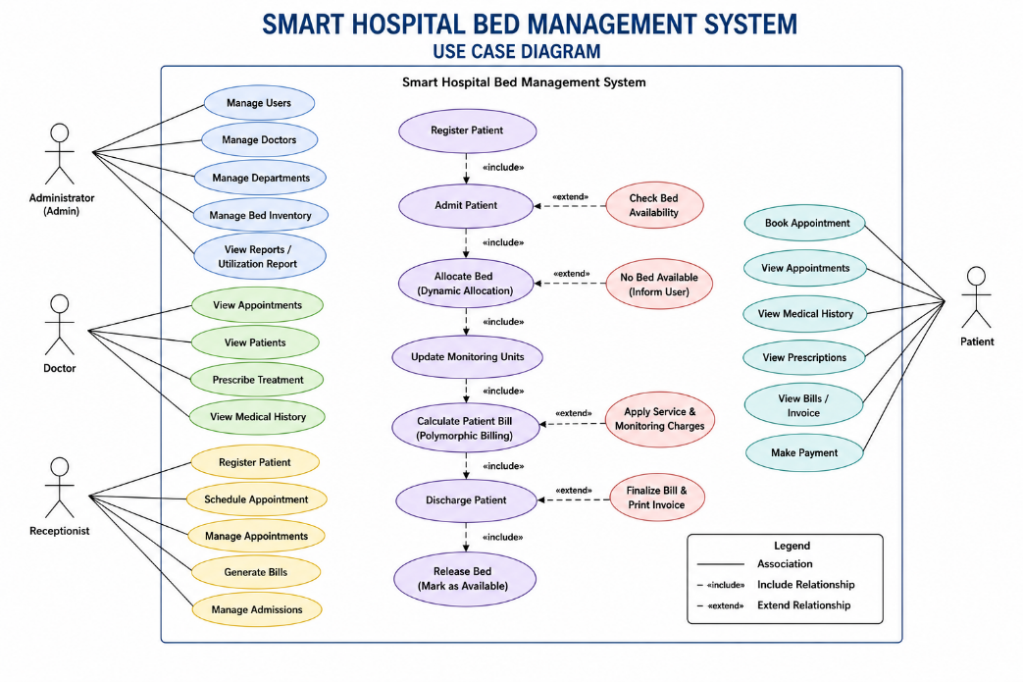
Figure 15.1: UML Use Case Diagram of the Smart Hospital Bed Management System
The major actor is the Hospital Staff / System User. Main use cases include Register Patient, View Patients, View Bed Status, Admit Patient, Update Monitoring, Calculate Bill, Discharge Patient, Compare Admissions, Generate Utilization Report, and Exit System.

16. System Architecture
The system follows a modular architecture.

16.1 User Interface Layer
The user interacts with the system through a console menu. The interface allows the user to select operations such as registering patients, displaying patients, viewing beds, admitting patients, updating monitoring, calculating bills, discharging patients, and viewing reports.

16.2 Controller Layer
The Hospital class acts as the central controller. It manages:
std::vector<std::unique_ptr<Patient>> patients;
std::vector<HospitalBed> beds;
std::vector<Admission> admissions;
The controller coordinates interactions between patient objects, beds, and admissions.

16.3 Patient Layer
Patient
├── GeneralPatient
├── ICUPatient
└── EmergencyPatient

16.4 Bed Layer
The HospitalBed class represents a physical bed. It stores the Bed ID, ward type, occupancy state, and assigned patient ID.

16.5 Admission Layer
The Admission class stores information about a patient’s hospital stay, including admission ID, patient ID, bed ID, days stayed, monitoring units, active status, and total bill.

16.6 Runtime Execution
User
↓
Main Menu
↓
Hospital Controller
↓
Patient Base Pointer
↓
Virtual Function
↓
Derived Class Implementation
↓
Operation Result
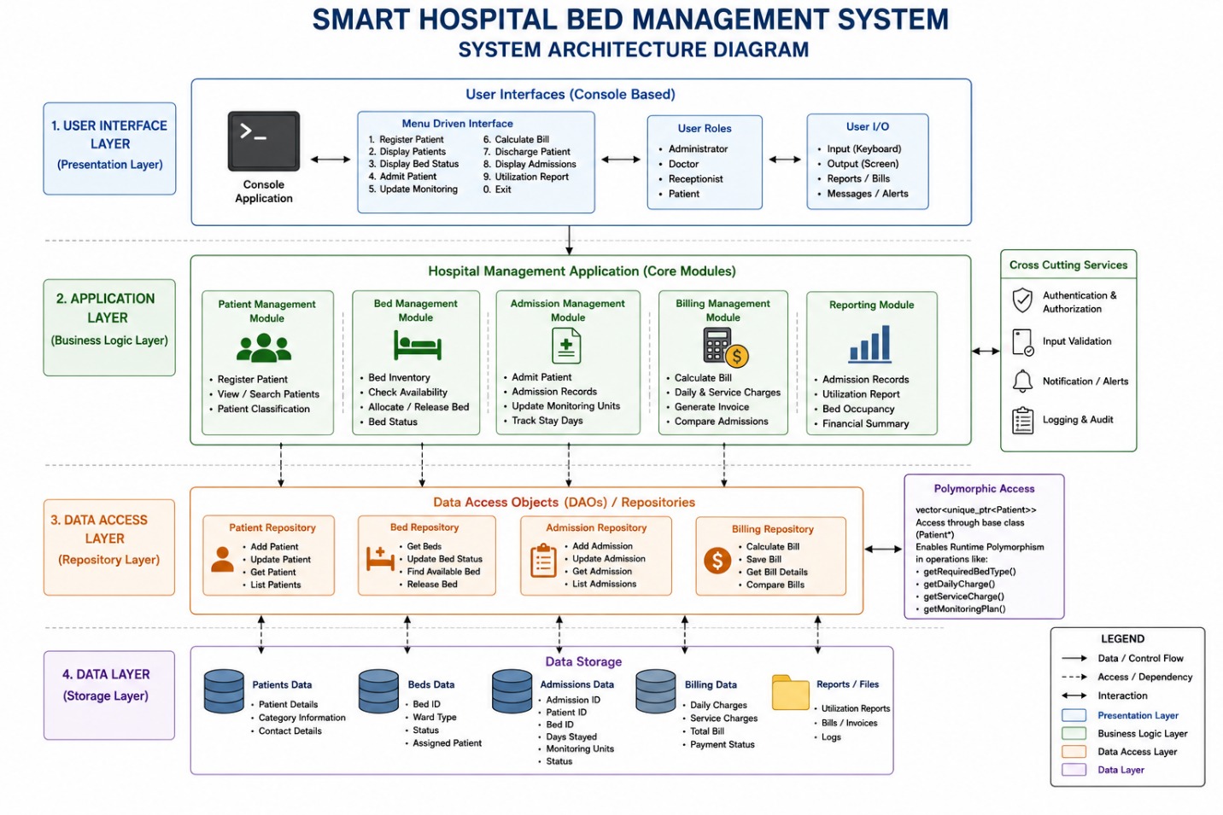
Figure 16.1: System Architecture of the Smart Hospital Bed Management System

17. Class Design

17.1 Patient Class
Patient is the abstract base class. It contains common patient information: Patient ID, Name, Age, Gender, and Contact. It declares pure virtual functions:
virtual std::string getPatientType() const = 0;
virtual std::string getRequiredBedType() const = 0;
virtual double getDailyCharge() const = 0;
virtual double getServiceCharge() const = 0;
virtual std::string getMonitoringPlan() const = 0;
virtual int getPriorityScore() const = 0;
It also contains a virtual destructor:
virtual ~Patient() = default;
This is essential when derived objects are handled through base-class pointers.

17.2 GeneralPatient
GeneralPatient publicly inherits from Patient. Additional attributes may include insurance status and general ward preference. Its virtual functions provide General-specific behavior.
Function | General Result
getPatientType() | General Patient
getRequiredBedType() | General
getDailyCharge() | $150
getServiceCharge() | $25
getMonitoringPlan() | Standard Nurse Check
getPriorityScore() | 1–3

17.3 ICUPatient
ICUPatient publicly inherits from Patient. Additional attributes include ventilator requirement and criticality level. Its virtual functions provide ICU-specific behavior.
Function | ICU Result
getPatientType() | ICU Patient
getRequiredBedType() | ICU
getDailyCharge() | $1,200
getServiceCharge() | $150
getMonitoringPlan() | Continuous Telemetry
getPriorityScore() | 8–10

17.4 EmergencyPatient
EmergencyPatient publicly inherits from Patient. Additional attributes include triage code and trauma level. Its virtual functions provide Emergency-specific behavior.
Function | Emergency Result
getPatientType() | Emergency Patient
getRequiredBedType() | Emergency
getDailyCharge() | $500
getServiceCharge() | $75
getMonitoringPlan() | Continuous Triage Evaluation
getPriorityScore() | 7–9

17.5 HospitalBed
The HospitalBed class represents a physical hospital bed.
Attributes: bedId, wardType, isOccupied, assignedPatientId.
Operations: allocateBed(patientId), releaseBed(), isAvailable().

17.6 Admission
The Admission class represents a patient stay.
Attributes: admissionId, patientId, bedId, daysStayed, monitoringUnits, isActive, totalBill.
It also supports operator overloading. operator> can compare two admission records according to total billing. operator<< can provide formatted admission output.

17.7 Hospital
The Hospital class acts as the central management engine. Major operations include registerPatient(), admitPatient(), updateMonitoring(), calculateBill(), dischargePatient(), and generateUtilizationReport().
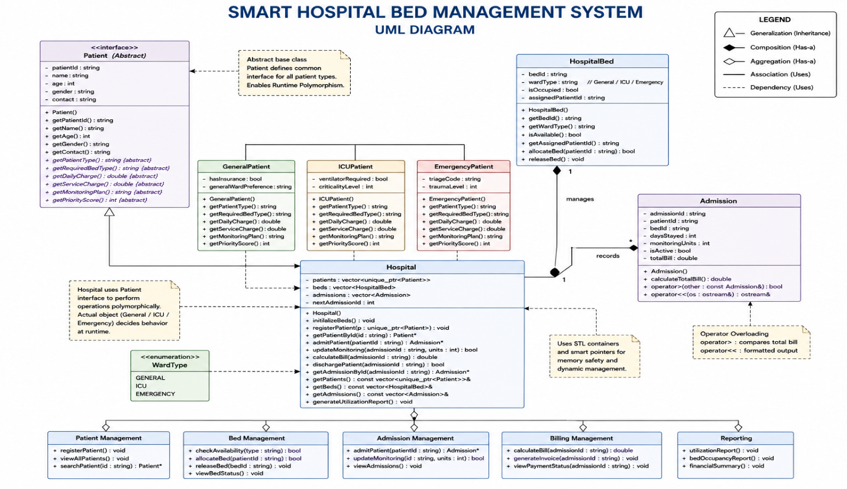
Figure 17.1: UML Class Diagram of the Smart Hospital Bed Management System

18. Runtime Polymorphism – Main Concept

18.1 Definition
Runtime Polymorphism is the ability of a program to determine which overridden function implementation should be executed at runtime. In C++, runtime polymorphism is commonly achieved through inheritance, virtual functions, base-class pointers or references, and dynamic binding.

18.2 Runtime Polymorphism in This Project
Patient*
|
+---- GeneralPatient
|
+---- ICUPatient
|
+---- EmergencyPatient
The same base-class pointer can refer to objects of different derived types. For example, Patient* patient; could refer to GeneralPatient, ICUPatient, or EmergencyPatient. When the following statement is executed:
patient->getDailyCharge();
C++ determines which implementation should execute according to the runtime object.

18.3 Virtual Functions
The base class declares virtual double getDailyCharge() const = 0;. Each derived class overrides it: General returns 150, ICU returns 1200, Emergency returns 500. The hospital controller does not need three separate billing functions.

18.4 Dynamic Bed Allocation
The system executes std::string bedType = patient->getRequiredBedType();. If the patient is an ICU object, the runtime call returns “ICU”; if General, it returns “General”; if Emergency, it returns “Emergency”. The bed-management algorithm can then search for a matching available bed.

18.5 Dynamic Billing
Billing is calculated using: Total Bill = (Days Stayed × Daily Charge) + (Monitoring Units × Service Charge).
Suppose an ICU patient stays for 3 days and has 4 monitoring units:
Daily component = 3 × $1,200 = $3,600
Monitoring component = 4 × $150 = $600
Total = $4,200
The important point is that the billing function obtains the rates dynamically from the patient object.

18.6 Dynamic Monitoring
The monitoring plan is also determined polymorphically: General → Standard Nurse Check, ICU → Continuous Telemetry, Emergency → Continuous Triage Evaluation.

18.7 Dynamic Priority
The system can obtain a patient’s priority through patient->getPriorityScore();. The actual implementation depends on the runtime patient type.

18.8 Virtual Table Concept
A class containing virtual functions is conceptually associated with a virtual function table. A simplified representation is:
Patient*
|
v
Object
|
vptr
|
v
Virtual Table
|
+--> getPatientType()
+--> getRequiredBedType()
+--> getDailyCharge()
+--> getServiceCharge()
+--> getMonitoringPlan()
+--> getPriorityScore()
For an ICU object, the virtual dispatch mechanism selects the ICU implementations. This is a conceptual description of how the compiler and runtime implement dynamic dispatch, and it is not something manually programmed within the project.

18.9 Virtual Function Mapping
Table 18.1: Virtual Function Mapping
Virtual Function | GeneralPatient | ICUPatient | EmergencyPatient
getPatientType() | General Patient | ICU Patient | Emergency Patient
getRequiredBedType() | General | ICU | Emergency
getDailyCharge() | $150 | $1,200 | $500
getServiceCharge() | $25 | $150 | $75
getMonitoringPlan() | Standard Nurse Check | Continuous Telemetry | Continuous Triage Evaluation
getPriorityScore() | 1–3 | 8–10 | 7–9
Table 18.2: Runtime Dispatch Analysis
Call Site | Static Type | Runtime Type | Function Selected
patient->getDailyCharge() | Patient* | GeneralPatient | GeneralPatient::getDailyCharge()
patient->getDailyCharge() | Patient* | ICUPatient | ICUPatient::getDailyCharge()
patient->getDailyCharge() | Patient* | EmergencyPatient | EmergencyPatient::getDailyCharge()
patient->getRequiredBedType() | Patient* | ICUPatient | ICUPatient::getRequiredBedType()

18.10 Why Runtime Polymorphism Is the Main Concept
Runtime polymorphism is not merely included as a theoretical feature. It directly controls patient classification, bed selection, billing, monitoring plan, priority, and administrative processing. Therefore, the main software architecture is based on dynamic behavior through the Patient interface.

19. Supporting OOP Concepts

19.1 Classes and Objects
The project models real-world entities using classes, for example Patient, HospitalBed, Admission, and Hospital. Objects are created from these class definitions during program execution.

19.2 Encapsulation
Encapsulation combines data and behavior inside classes while restricting direct access to internal data. For example, patient information can be protected using private: std::string id; std::string name; int age;. Public getter and setter methods can provide controlled access.

19.3 Inheritance
The specialized patient classes inherit common functionality from Patient, for example class ICUPatient : public Patient. This avoids unnecessary duplication of common patient information.

19.4 Abstraction
The abstract Patient class defines what operations every patient must provide without defining every implementation. This allows the hospital controller to work with the general concept of a patient.

19.5 Pure Virtual Functions
Functions declared with = 0 are pure virtual functions. They force derived classes to provide implementations.

19.6 Virtual Destructor
The base class uses virtual ~Patient() = default;. This is important because derived objects are managed through base-class pointers.

19.7 Smart Pointers
The project uses std::unique_ptr<Patient>. This provides automatic memory ownership and cleanup.

19.8 STL Vector
The system uses std::vector to store dynamic collections, for example std::vector<std::unique_ptr<Patient>> and std::vector<HospitalBed>.

19.9 Operator Overloading
The Admission class uses operator overloading. operator> is used for comparing admission billing values. operator<< is used for formatted admission output.

19.10 Constructors
Constructors initialize objects when they are created. This ensures that patient, bed, and admission objects begin with meaningful values.

20. Requirement to Implementation Mapping
Table 20.1: Requirement-to-Implementation Mapping
System Requirement | OOP Concept | Implementation
Patient classification | Runtime Polymorphism | Patient hierarchy
Common patient interface | Abstraction | Abstract Patient
Patient specialization | Inheritance | Derived classes
Patient-specific behavior | Virtual Functions | Overridden methods
Bed selection | Runtime Polymorphism | getRequiredBedType()
Dynamic billing | Runtime Polymorphism | Rate getters
Monitoring | Runtime Polymorphism | getMonitoringPlan()
Priority | Runtime Polymorphism | getPriorityScore()
Memory management | Smart Pointers | unique_ptr
Bed management | Encapsulation | HospitalBed
Admission management | Classes/Objects | Admission
Bill comparison | Operator Overloading | operator>
Formatted output | Operator Overloading | operator<<
Dynamic collections | STL | vector
Safe destruction | Virtual Destructor | ~Patient()

21. Algorithms

21.1 Algorithm for Patient Registration
Input: Patient details and category. Output: Registered patient object.
- Start.
- Request patient category.
- Input patient ID.
- Check whether the ID already exists.
- If the ID exists, display an error.
- Otherwise input name, age, gender, and contact.
- If General is selected, input General-specific details.
- Create GeneralPatient.
- If ICU is selected, input ICU-specific details.
- Create ICUPatient.
- If Emergency is selected, input Emergency-specific details.
- Create EmergencyPatient.
- Store the object inside the polymorphic patient vector.
- Display successful registration.
- Stop.

21.2 Algorithm for Dynamic Bed Allocation
- Start.
- Input patient ID.
- Search for the patient.
- If patient does not exist, display error.
- Obtain the required bed type using patient->getRequiredBedType().
- Search through all beds.
- Check whether the bed is available.
- Check whether the bed’s ward type matches the required type.
- If a matching bed is found, allocate it.
- Create an admission record.
- Store the admission.
- Display successful allocation.
- If no matching bed is available, display allocation failure.
- Stop.

21.3 Algorithm for Monitoring Update
- Start.
- Input admission ID.
- Find the admission.
- Validate that the admission is active.
- Input monitoring units.
- Add the new units to the admission.
- Display the updated monitoring information.
- Stop.

21.4 Algorithm for Billing
- Start.
- Input admission ID.
- Find the admission.
- Find the associated patient.
- Call getDailyCharge().
- Call getServiceCharge().
- Retrieve days stayed.
- Retrieve monitoring units.
- Calculate: Total Bill = (Days Stayed × Daily Charge) + (Monitoring Units × Service Charge).
- Store the calculated amount.
- Display the bill.
- Stop.

21.5 Algorithm for Patient Discharge
- Start.
- Input admission ID.
- Find active admission.
- Find associated patient.
- Calculate final bill dynamically.
- Find assigned bed.
- Release the bed.
- Mark admission inactive.
- Display final billing information.
- Stop.

21.6 Algorithm for Admission Comparison
- Start.
- Select two admission records.
- Compare total bills.
- Invoke overloaded operator>.
- Display which admission has the higher bill.
- Stop.

21.7 Algorithm for Utilization Report
- Start.
- Count registered patients.
- Count active admissions.
- Count occupied beds.
- Count available beds.
- Group bed statistics by ward.
- Calculate occupancy percentages.
- Display summary.
- Stop.

22. Pseudocode

22.1 Patient Base Class
CLASS Patient
PROTECTED
id
name
age
gender
contact
PUBLIC
getPatientType() = PURE VIRTUAL
getRequiredBedType() = PURE VIRTUAL
getDailyCharge() = PURE VIRTUAL
getServiceCharge() = PURE VIRTUAL
getMonitoringPlan() = PURE VIRTUAL
getPriorityScore() = PURE VIRTUAL
virtual destructor
END CLASS

22.2 GeneralPatient
CLASS GeneralPatient INHERITS Patient
ATTRIBUTES
hasInsurance
generalWardPreference
FUNCTIONS
getPatientType()
RETURN "General Patient"
getRequiredBedType()
RETURN "General"
getDailyCharge()
RETURN 150
getServiceCharge()
RETURN 25
getMonitoringPlan()
RETURN "Standard Nurse Check"
getPriorityScore()
RETURN value between 1 and 3
END CLASS

22.3 ICUPatient
CLASS ICUPatient INHERITS Patient
ATTRIBUTES
ventilatorRequired
criticalityLevel
FUNCTIONS
getPatientType()
RETURN "ICU Patient"
getRequiredBedType()
RETURN "ICU"
getDailyCharge()
RETURN 1200
getServiceCharge()
RETURN 150
getMonitoringPlan()
RETURN "Continuous Telemetry"
getPriorityScore()
RETURN value between 8 and 10
END CLASS

22.4 EmergencyPatient
CLASS EmergencyPatient INHERITS Patient
ATTRIBUTES
triageCode
traumaLevel
FUNCTIONS
getPatientType()
RETURN "Emergency Patient"
getRequiredBedType()
RETURN "Emergency"
getDailyCharge()
RETURN 500
getServiceCharge()
RETURN 75
getMonitoringPlan()
RETURN "Continuous Triage Evaluation"
getPriorityScore()
RETURN value between 7 and 9
END CLASS

22.5 Dynamic Bed Allocation
FUNCTION admitPatient(patientID)
patient = findPatient(patientID)
IF patient == NULL
PRINT "Patient not found"
RETURN
END IF
requiredBed = patient->getRequiredBedType()
FOR each bed IN beds
IF bed.isAvailable() AND bed.wardType == requiredBed
bed.allocateBed(patientID)
create Admission
add Admission to admissions
PRINT "Bed allocated successfully"
RETURN
END IF
END FOR
PRINT "No suitable bed available"
END FUNCTION

22.6 Dynamic Billing
FUNCTION calculateBill(admissionID)
admission = findAdmission(admissionID)
IF admission == NULL
PRINT "Admission not found"
RETURN
END IF
patient = findPatient(admission.patientID)
dailyRate = patient->getDailyCharge()
serviceRate = patient->getServiceCharge()
total = admission.daysStayed * dailyRate
+ admission.monitoringUnits * serviceRate
admission.totalBill = total
PRINT total
END FUNCTION

23. Flowchart
The overall program execution is represented below.
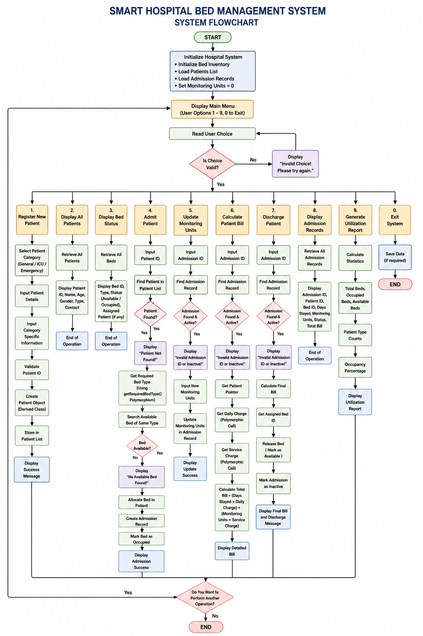
Figure 23.1: Overall System Execution Flowchart

24. Detailed Module Implementation

24.1 Patient Management Module
The Patient Management Module is responsible for registering and maintaining patient objects. The module creates derived patient objects according to the category selected by the user. The objects are stored polymorphically:
std::vector<std::unique_ptr<Patient>> patients;
This allows the hospital controller to maintain General, ICU, and Emergency objects inside one collection.

24.2 Bed Management Module
The Bed Management Module manages the physical hospital bed resources. Each HospitalBed object contains information about the bed identifier, ward type, occupancy state, and assigned patient. The module provides operations to allocate and release beds.

24.3 Admission Module
The Admission Module creates records connecting Patient → Bed → Hospital Stay. The admission record maintains the admission ID, patient ID, bed ID, days stayed, monitoring units, bill, and active status.

24.4 Runtime Polymorphism Module
This is the central module. The Hospital controller uses a base-class pointer, Patient* patient;, and then invokes virtual functions. The implementation is selected at runtime.

24.5 Billing Module
The Billing Module calculates costs using Room Charges + Service Charges. The rates are obtained dynamically from the patient’s runtime class.

24.6 Discharge Module
The Discharge Module locates the admission, calculates the final bill, releases the bed, marks the admission inactive, and displays the final details.

24.7 Reporting Module
The Reporting Module summarizes total patients, active admissions, occupied beds, available beds, ward-level utilization, and patient category distribution.

25. Source Code Implementation

25.1 Project Directory Structure
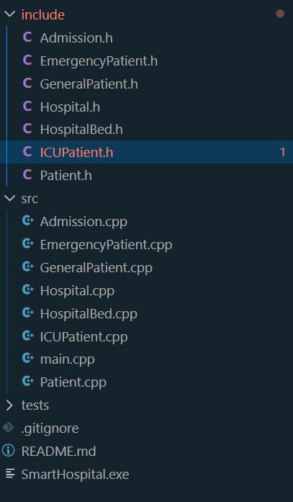
Figure 25.1: Multi-file project directory structure in VS Code

25.2 Patient.h
The abstract base class declares the common patient interface.
class Patient {
protected:
std::string id;
std::string name;
int age;
std::string gender;
std::string contact;
public:
virtual ~Patient() = default;
virtual std::string getPatientType() const = 0;
virtual std::string getRequiredBedType() const = 0;
virtual double getDailyCharge() const = 0;
virtual double getServiceCharge() const = 0;
virtual std::string getMonitoringPlan() const = 0;
virtual int getPriorityScore() const = 0;
};
This file represents the foundation of Runtime Polymorphism.

25.3 GeneralPatient
The General Patient class overrides the virtual functions and provides General-specific behavior.

25.4 ICUPatient
The ICU Patient class provides specialized ICU requirements.

25.5 EmergencyPatient
The Emergency Patient class provides emergency-specific behavior.

25.6 HospitalBed
The bed class manages availability and assignment.

25.7 Admission
The admission class maintains stay information and supports overloaded operators.

25.8 Hospital
The Hospital class manages all collections and system operations. A key polymorphic operation is:
std::string neededBedType = patient->getRequiredBedType();
The Hospital class does not need to determine the concrete class manually.

26. Program Compilation and Execution

26.1 Compilation
The complete project can be compiled using:
g++ -std=c++17 -Iinclude src/main.cpp src/Patient.cpp src/GeneralPatient.cpp src/ICUPatient.cpp src/EmergencyPatient.cpp src/HospitalBed.cpp src/Admission.cpp src/Hospital.cpp -o SmartHospital.exe
The command compiles all source files and links them into the executable SmartHospital.exe.

26.2 Execution
The program can be launched using:
.\SmartHospital.exe

26.3 Compilation Verification
The compilation should complete without compiler errors.
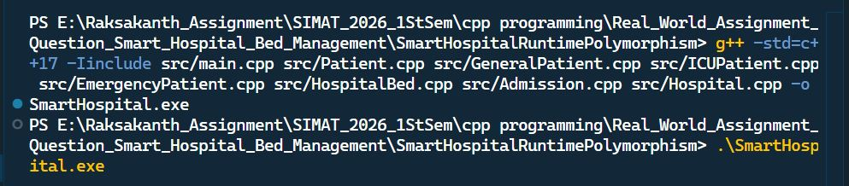
Figure 26.1: Multi-file C++ compilation and execution in VS Code

27. Testing and Validation
Testing ensures that the system behaves according to its requirements. Testing is divided into functional testing, input validation, boundary testing, polymorphism testing, bed allocation testing, billing testing, discharge testing, and reporting testing.
Table 27.1: System Test Case Matrix
Test ID | Feature | Test Input | Expected Result
TC01 | General registration | Valid General patient | Registration successful
TC02 | ICU registration | Valid ICU patient | Registration successful
TC03 | Emergency registration | Valid Emergency patient | Registration successful
TC04 | Duplicate ID | Existing patient ID | Registration rejected
TC05 | Invalid age | Negative/out-of-range age | Input rejected
TC06 | General allocation | General patient | General bed assigned
TC07 | ICU allocation | ICU patient | ICU bed assigned
TC08 | Emergency allocation | Emergency patient | Emergency bed assigned
TC09 | Capacity exceeded | No suitable bed | Allocation rejected
TC10 | Monitoring update | Valid admission | Monitoring updated
TC11 | Dynamic billing | ICU admission | Correct ICU rate used
TC12 | Discharge | Active admission | Patient discharged
TC13 | Bed release | Discharged patient | Bed becomes available
TC14 | Operator > | Two admissions | Correct comparison
TC15 | Utilization report | Report option | Statistics displayed
TC16 | Invalid menu | Invalid option | Error handled

27.1 Functional Testing
Functional testing verifies that each menu operation performs the intended task.

27.2 Boundary Testing
Boundary testing is applied to values such as age, priority, monitoring units, and menu choices.

27.3 Polymorphism Testing
Polymorphism is verified by registering different patient types and observing that the same base-class interface produces different results. For example, patient->getRequiredBedType(); must produce “General” for a General patient, “ICU” for an ICU patient, and “Emergency” for an Emergency patient.

27.4 Billing Testing
Billing is tested using Total = (Days × Daily Rate) + (Monitoring Units × Service Rate). Example (ICU): 3 days × $1,200 = $3,600; 4 units × $150 = $600; Total = $4,200.

27.5 Discharge Testing
Discharge testing verifies that the bill is calculated, the admission becomes inactive, and the assigned bed becomes available.

29. Sample Program Output
The following is a representative example of the type of output expected from the application.
========================================================
SMART HOSPITAL BED MANAGEMENT SYSTEM
========================================================
1. Register New Patient
2. Display All Patients
3. Display Bed Status
4. Admit Patient
5. Update Monitoring Units
6. Calculate Patient Bill
7. Discharge Patient
8. Display Admission Records
9. Generate Hospital Utilization Report
0. Exit
Enter Choice:

29.1 Sample ICU Registration
Select Patient Category:
1. General
2. ICU
3. Emergency
Enter Choice: 2
Enter Patient ID: P102
Enter Name: Sarah
Enter Age: 52
Enter Gender: Female
Enter Contact: 9876543210
Ventilator Required: Yes
Criticality Level: 4
SUCCESS: ICU Patient registered successfully.

29.2 Sample Dynamic Bed Allocation
Enter Patient ID for Admission: P102
[POLYMORPHIC DISPATCH]
Calling getRequiredBedType()...
Required Bed Type: ICU
Searching available beds...
Available Bed Found: BED-ICU-01
SUCCESS:
Patient Sarah allocated to BED-ICU-01

29.3 Sample Dynamic Billing
Enter Admission ID: ADM-101
[POLYMORPHIC DISPATCH]
Patient Type: ICU Patient
Daily Rate: $1200.00
Service Rate: $150.00
Days Stayed: 3
Monitoring Units: 4
Room Charges:
3 x $1200.00 = $3600.00
Monitoring Charges:
4 x $150.00 = $600.00
----------------------------------------
TOTAL BILL: $4200.00
----------------------------------------
The output demonstrates that the correct ICU rates are obtained through the patient interface rather than through a separate ICU-specific billing algorithm.

30. Design Decisions and Justification

30.1 Runtime Polymorphism
Runtime polymorphism was selected as the central design mechanism because different patient categories have different behavior. The controller can therefore use Patient* instead of depending on concrete classes.

30.2 Abstract Patient Class
Patient acts as a contract. Every derived patient class must provide implementations for the required virtual functions.

30.3 Derived Classes
The three derived classes encapsulate specialized behavior. This keeps patient-specific rules in the appropriate class.

30.4 Smart Pointers
std::unique_ptr provides automatic ownership and cleanup. This reduces the risk of memory leaks, double deletion, and dangling pointers.

30.5 STL Vector
Vectors provide convenient dynamic collections. The polymorphic patient collection is std::vector<std::unique_ptr<Patient>>.

30.6 Hospital Controller
The Hospital class coordinates operations while avoiding unnecessary knowledge of concrete patient types. This improves separation of responsibilities.

30.7 Separate Bed and Admission Classes
A hospital bed is a physical resource, while an admission represents a patient’s stay. Separating these concepts improves the structure of the program.

30.8 Operator Overloading
Operator overloading makes admission comparison and output easier to read.

31. Comparison with Alternative Approach
Table 31.1: Procedural Approach versus Runtime Polymorphism
Factor | Procedural Conditional Design | Polymorphic Design
Patient handling | Type-based conditions | Base-class interface
Bed allocation | Conditional branches | Virtual function
Billing | Type checks | Virtual rate methods
Monitoring | Conditional logic | Overridden method
Extensibility | Requires modifying controller | Add derived class
Maintainability | Lower | Higher
Code duplication | Higher | Lower
Separation of concerns | Limited | Stronger
Memory management | May require manual handling | Smart pointers
Central controller dependency | High | Lower

31.1 Procedural Example
A procedural approach may use:
if(type == "General")
{
rate = 150;
}
else if(type == "ICU")
{
rate = 1200;
}
else
{
rate = 500;
}
If another patient type is introduced, this code must be modified.

31.2 Polymorphic Example
The implemented approach uses:
double rate = patient->getDailyCharge();
The object determines its own rate. This demonstrates the practical benefit of runtime polymorphism.

32. Advantages
32.1 Extensibility. New patient categories can be introduced by creating new derived classes.
32.2 Maintainability. Patient-specific logic remains within the relevant class.
32.3 Reduced Conditional Logic. The controller does not require repeated type checks.
32.4 Reusability. The common Patient interface can be reused by many hospital operations.
32.5 Memory Safety. Smart pointers automatically manage dynamic memory.
32.6 Modularity. The multi-file structure separates interfaces and implementations.
32.7 Clear Architecture. The system has distinct responsibilities for patients, beds, admissions, hospital control, billing, and reporting.
32.8 Demonstration of OOP. The project demonstrates several important C++ concepts within one practical application.

33. Limitations
The current implementation has several limitations.
33.1 No Database. All records are maintained in memory. When the application terminates, runtime data is lost.
33.2 Console Interface. The application uses a command-line interface instead of a graphical interface.
33.3 Single User. The current application is designed for local single-user execution.
33.4 No Real-Time Medical Devices. Monitoring values are entered or simulated by the user. The project does not directly connect to medical sensors.
33.5 Simplified Billing. The billing model is intentionally simplified for academic demonstration. Real hospitals may have significantly more complex billing structures.
33.6 Educational Scope. The application is intended to demonstrate software engineering and C++ OOP concepts. It should not be considered a production clinical management system.

34. Future Enhancements
34.1 Database Integration. A database such as SQLite, MySQL, or PostgreSQL could be introduced to store patient and admission records permanently.
34.2 Graphical User Interface. A GUI could make bed availability and patient information easier to visualize.
34.3 Web-Based Dashboard. A web dashboard could allow authorized hospital staff to access bed information remotely.
34.4 Authentication. The system could implement secure user authentication. Different users could have different permissions.
34.5 Role-Based Access. Roles could include Administrator, Doctor, Nurse, Billing Officer, and Receptionist.
34.6 Real-Time Bed Monitoring. Sensors could provide automatic information about bed occupancy.
34.7 Additional Patient Classes. Future derived classes could include PediatricPatient, MaternityPatient, SurgicalPatient, and CardiacPatient. This would further demonstrate the extensibility of the polymorphic architecture.
34.8 Hospital Networking. Multiple departments could share bed availability information.
34.9 Cloud Deployment. The system could eventually become a cloud-connected hospital resource management application.
34.10 Advanced Analytics. Future versions could analyze bed utilization, average stay, ward demand, admission trends, and resource requirements.

35. Ethical and Professional Considerations
Healthcare-related software requires responsible design because patient information can be sensitive and operational errors can have serious consequences.
35.1 Patient Privacy. Real-world implementations must protect personal and medical information.
35.2 Data Security. Sensitive information should be protected against unauthorized access.
35.3 Data Integrity. Patient and admission records must remain accurate.
35.4 Fair Resource Allocation. Automated bed allocation should be based on defined operational rules rather than unfair or arbitrary criteria.
35.5 Reliable Billing. Incorrect billing can cause administrative and financial problems. Therefore, billing calculations must be tested carefully.
35.6 Input Validation. Invalid patient information and invalid menu selections must be handled safely.
35.7 Professional Responsibility. Real healthcare applications require extensive validation, security testing, auditing, documentation, and compliance procedures. The current project is an academic simulation and does not claim clinical certification.

36. SDG Relevance

Sustainable Development Goal 3 – Good Health and Well-Being
The project is related to United Nations Sustainable Development Goal 3: Good Health and Well-Being. Efficient healthcare resource management can support hospitals in using their available resources more effectively. The Smart Hospital Bed Management System demonstrates how software can organize bed availability, patient classification, patient admission, monitoring records, billing, and resource utilization.
Although the current implementation is an educational simulation, the underlying software engineering principles are relevant to healthcare resource-management systems.

36.1 Relationship with Healthcare Efficiency
A better-organized bed management process can help hospital administrators understand resource availability and allocation.

36.2 Resource Utilization
The utilization-reporting module demonstrates how software can summarize the current use of hospital beds.

36.3 Emergency Resource Management
The Emergency Patient category demonstrates the importance of distinguishing urgent resource requirements from standard admissions.

37. Learning Outcomes
The development of this project provided practical understanding of several C++ and software-engineering concepts.
37.1 Runtime Polymorphism. The project demonstrated how virtual functions and base-class pointers can provide dynamic behavior.
37.2 Abstract Classes. The Patient class demonstrates how an abstract interface can define a common contract.
37.3 Inheritance. Derived classes reuse common patient attributes while implementing specialized behavior.
37.4 Encapsulation. Class data is protected through controlled access.
37.5 Smart Pointers. The project provided practical experience with std::unique_ptr.
37.6 STL. The project uses std::vector to manage dynamic collections.
37.7 Operator Overloading. The Admission class demonstrates custom operators.
37.8 Multi-File Compilation. The project demonstrates how .h and .cpp files are organized and compiled together.
37.9 Algorithm Design. The project required algorithms for registration, allocation, billing, monitoring, discharge, and reporting.
37.10 Testing. The test matrix helped identify normal, boundary, and invalid-input scenarios.

38. Student Reflection
Developing the Smart Hospital Bed Management System provided practical experience in applying Object-Oriented Programming concepts to a real-world-inspired software problem.
Initially, the different patient categories could be viewed as separate cases requiring separate conditional statements. However, designing the project around Runtime Polymorphism provided a better way to represent the differences.
The most important learning outcome was understanding how an abstract base class can define a common interface while derived classes provide specialized behavior. For example, the Hospital class does not need to determine whether a patient is an ICU patient before requesting the required bed type. It simply calls patient->getRequiredBedType();. The runtime object provides the correct implementation. This helped demonstrate the practical meaning of dynamic binding.
The project also improved my understanding of memory management in modern C++. Using std::unique_ptr<Patient> made it possible to store heterogeneous derived objects while allowing automatic memory cleanup.
Another important learning experience was organizing the project into separate header and source files. Separating declarations from implementations improved the structure of the project and made debugging easier.
Testing the application also demonstrated that software design is not complete after writing the code. Each module must be validated using normal and invalid inputs.
Overall, this project helped connect theoretical concepts such as abstraction, inheritance, virtual functions, and polymorphism with a practical application involving hospital resource management.

39. Conclusion
The Smart Hospital Bed Management System demonstrates how Object-Oriented Programming and Runtime Polymorphism can be applied to a practical resource-management problem.
The system uses an abstract Patient class as the common interface for multiple patient categories. GeneralPatient, ICUPatient, and EmergencyPatient inherit from this base class and provide specialized implementations for bed requirements, billing rates, monitoring plans, patient classification, and priority.
The central Hospital controller works with patients through base-class pointers and smart pointers rather than depending directly on concrete patient classes. This allows virtual functions to determine the correct behavior dynamically at runtime.
Runtime polymorphism is therefore used directly in important system operations including patient classification, dynamic bed allocation, monitoring-plan selection, priority determination, and billing calculation.
The project also incorporates encapsulation, inheritance, abstraction, virtual destructors, smart pointers, STL vectors, constructors, operator overloading, input validation, and modular source organization.
The system demonstrates that a polymorphic architecture can reduce repeated conditional logic and make the software easier to extend. A future patient category can be implemented as a new derived class while preserving the common interface used by the Hospital controller.
Although the current application is a console-based academic simulation without persistent storage or real medical-device integration, it successfully demonstrates the intended C++ concepts.
Therefore, the project achieves its primary objective of demonstrating Runtime Polymorphism as the central architectural mechanism for dynamic hospital bed management.

40. References
- Stroustrup, B. The C++ Programming Language. 4th Edition, Addison-Wesley Professional.
- Lippman, S. B., Lajoie, J., and Moo, B. E. C++ Primer. 5th Edition, Addison-Wesley Professional.
- Meyers, S. Effective Modern C++. O’Reilly Media.
- Gamma, E., Helm, R., Johnson, R., and Vlissides, J. Design Patterns: Elements of Reusable Object-Oriented Software. Addison-Wesley.
- ISO/IEC. Programming Languages — C++. International Standard.
- cppreference. Virtual Functions and Dynamic Binding in C++.
- cppreference. std::unique_ptr – C++ Standard Library Reference.
- cppreference. std::vector – C++ Standard Library Reference.
- United Nations. Sustainable Development Goal 3: Good Health and Well-Being.

41. Appendix

Appendix A – Complete Source Code Directory
The complete project source code is organized into the following directories:
SmartHospitalRuntimePolymorphism/
│
├── include/
│ ├── Patient.h
│ ├── GeneralPatient.h
│ ├── ICUPatient.h
│ ├── EmergencyPatient.h
│ ├── HospitalBed.h
│ ├── Admission.h
│ └── Hospital.h
│
└── src/
├── main.cpp
├── Patient.cpp
├── GeneralPatient.cpp
├── ICUPatient.cpp
├── EmergencyPatient.cpp
├── HospitalBed.cpp
├── Admission.cpp
└── Hospital.cpp

Appendix B – Source Code Evidence
Exhibit B.1 – Abstract Patient Interface. [INSERT SCREENSHOT OF Patient.h HERE]. The screenshot should clearly show:
virtual std::string getRequiredBedType() const = 0;
virtual double getDailyCharge() const = 0;
virtual double getServiceCharge() const = 0;
Caption: Exhibit B.1: Abstract Patient interface and pure virtual functions
Exhibit B.2 – Runtime Polymorphism in Hospital.cpp. [INSERT SCREENSHOT OF Hospital.cpp HERE]. Highlight:
patient->getRequiredBedType();
patient->getDailyCharge();
patient->getServiceCharge();
Caption: Exhibit B.2: Runtime polymorphic calls inside the Hospital controller

Appendix C – Screenshot Gallery
Insert the complete collection of actual execution screenshots here. Recommended screenshots: project folder structure; compilation; main menu; General registration; ICU registration; Emergency registration; patient display; bed status; General allocation; ICU allocation; Emergency allocation; monitoring update; billing; admission records; admission comparison; utilization report; discharge; invalid input.

Appendix D – GitHub Repository
Project Repository: [https://github.com/VirendarSingh-07/C-.git]
Repository Name: SmartHospitalRuntimePolymorphism
Description: C++17 Smart Hospital Bed Management System demonstrating Runtime Polymorphism, inheritance, abstraction, dynamic bed allocation, monitoring, billing, admission management, and hospital utilization reporting.
[INSERT GITHUB QR CODE HERE]

Appendix E – Additional Diagrams
E.1 Use Case Diagram — [INSERT USE CASE DIAGRAM HERE]
E.2 Class Diagram — [INSERT UML CLASS DIAGRAM HERE]
E.3 System Architecture — [INSERT SYSTEM ARCHITECTURE DIAGRAM HERE]
E.4 Runtime Polymorphism Diagram — [INSERT RUNTIME POLYMORPHISM DIAGRAM HERE]
E.5 Overall Flowchart — [INSERT FLOWCHART HERE]

42. Final Requirement Audit
Table 42.1: Final Requirement Verification Audit
Requirement | Implementation | Evidence | Status
C++ Project | C++17 source code | Project files | FULLY MET
Object-Oriented Design | Multiple classes | Class diagram | FULLY MET
Abstraction | Abstract Patient | Patient.h | FULLY MET
Inheritance | Three derived classes | UML diagram | FULLY MET
Runtime Polymorphism | Virtual functions | Hospital.cpp | FULLY MET
Dynamic Binding | Base-class pointer calls | Execution evidence | FULLY MET
General Patient | GeneralPatient | Registration test | FULLY MET
ICU Patient | ICUPatient | Registration test | FULLY MET
Emergency Patient | EmergencyPatient | Registration test | FULLY MET
Dynamic Bed Allocation | getRequiredBedType() | Allocation screenshots | FULLY MET
Monitoring | Monitoring functions | Monitoring screenshot | FULLY MET
Dynamic Billing | Rate virtual functions | Billing screenshot | FULLY MET
Admission Management | Admission class | Admission output | FULLY MET
Bed Release | releaseBed() | Discharge evidence | FULLY MET
Operator Overloading | > and << | Admission module | FULLY MET
Smart Pointers | unique_ptr | Source code | FULLY MET
STL Vector | vector collections | Source code | FULLY MET
Input Validation | Validation routines | Error screenshot | FULLY MET
Multi-file Structure | .h and .cpp files | Directory screenshot | FULLY MET
Testing | Test matrix | Chapter 27 | FULLY MET
Compilation Evidence | G++ build | Figure 26.1 | PENDING SCREENSHOT
Execution Evidence | Terminal screenshots | Chapter 28 | PENDING SCREENSHOTS
GitHub Repository | Repository link | Appendix D | PENDING LINK

Final Project Summary
The Smart Hospital Bed Management System is a C++17 console application developed to demonstrate how Runtime Polymorphism can be applied to a practical hospital resource-management problem. The system is centered around:
ABSTRACT PATIENT
|
+----------------+----------------+
| | |
v v v
GENERAL PATIENT ICU PATIENT EMERGENCY PATIENT
| | |
+----------------+----------------+
|
v
RUNTIME POLYMORPHISM
|
+----------------+----------------+
| | |
v v v
BED TYPE MONITORING BILLING
| | |
+----------------+----------------+
|
v
HOSPITAL CONTROLLER
The central idea is that the Hospital controller communicates with patient objects through a common interface while the runtime object determines the actual behavior. This design demonstrates the practical value of Runtime Polymorphism in creating software that is modular, extensible, maintainable, and easier to adapt to future requirements.

